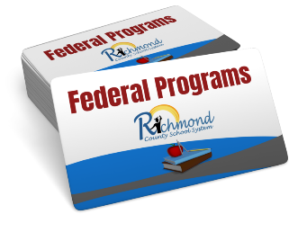

**Willis Foreman Elementary School**

**ADDRESS 2413 Willis Foreman Road, Hephzibah, GA 30815**

**PHONE #s 706-592-3991**

**PRINCIPAL**

**Title I Annual Meeting**

**Thursday, October 13 2022 @ 5:30 (before the PTO meeting)**

**Location: Cafeteria**

**ATTENTION: ALL PARENTS**

**Please make plans to attend and participate in this very important meeting as we discuss and revisit the many aspects of Title I Parent Engagement for the 2022-2023 School year. Your presence and participation will be greatly appreciated.**

***Topics of discussion will be as follows:***

**Title I Program Parents Right to Know**

**School-Parent Compact Parent and Family Engagement Policy**

**Budget/Funding Building Capacity**

**Assessments Curriculum**

**Volunteer Opportunities School Goals**

**School Improvement**

**Parents, we need you! You do not want to miss this opportunity to learn about and participate in the Title I Parent and Family Engagement program at your school!**

**For more information, contact the school office or your parent facilitator/designee:**

**Amelia Adams, Instructional Specialist**